|  |  |  |
| --- | --- | --- |
| **Invention Disclosure Form**  Graphic Era Hill University, Dehradun  www.gehu.ac.in | *FOR USE BY IPR Cell* | |
| *DATE FORM RECEIVED* | *NLO FILE NO.* |
| **INSTRUCTIONS:**  Fill each blank with the requested information or enter "NONE" as appropriate. Where space on the form is inadequate, enter "see attached page" and use plain pages as needed. When completely executed, this form becomes an important legal document useful in proving priority of invention. After completing, hand over in person to: **IPR Cell, GEHU.** You may also email **at ip@gehu.ac.in.** If you have any questions, feel free to contact us. | | |

**PART I. BASIC INFORMATION**

**1a. DESCRIPTIVE INVENTION TITLE.**

Armrest Mounted Vehicle Controller (AMVC)

|  |  |  |  |
| --- | --- | --- | --- |
| **1b. INVENTOR(S)** | Department and affiliation | Designation | Email-id |
|  |  |  |  |
|  |  |  |  |
| Mr. Satyam Parashar | Department of CSE, Graphic Era Hill University, Dehradun | Student | Satyamparashar1208@gmail.com |
|  |  |  |  |

**1c. OWNER.** Do the above inventor(s) own the patent rights to this invention (check one)? **[✓] Yes [ ] No** If you answered "No," please identify the owner of the invention below including the state/country of organization for the company along with the company's mailing address.

**1d. PRIOR USE, SALE, OR PUBLICATION.** Identify any past use, sale, display, or publication of the invention (include dates)

**PART II. DISCLOSURE OF INVENTION**

**2a. PURPOSE:**

The purpose of the smart traffic management and Incentivized travel device for the highest quality urban Mobility is to beautify urban mobility and alleviate site visitor congestion via using a multifaceted technique that harnesses data analytics, real-time visitor monitoring, and conduct-driven incentives. This machine aims to obtain the following targets:

1. **Site visitors float Optimization**: The system's primary intention is to optimize traffic waft within city areas via studying actual-time statistics and presenting dynamic steering to individuals, helping them choose much less congested journey instances and routes.
2. **Congestion discoun**t: By encouraging travel outside of peak hours through incentives and special offers, the system seeks to substantially lessen visitor congestion all through historically busy durations, thereby enhancing the overall exceptional of life for urban citizens.
3. **more suitable Transportation performance**: Through the integration of smart technologies and information-pushed tips, the machine strives to make urban transportation extra green and responsive to the desires of the network, making sure that humans can get to their destinations in a well-timed and trouble-unfastened way.
4. **Sustainable city Transportation**: By lowering congestion and optimizing visitor sign timings, this gadget contributes to a more sustainable city transportation ecosystem, in the end leading to decreased gas consumption, lower emissions, and a cleaner environment.
5. **Community Engagement**: The gadget fosters network engagement by way of providing focused incentives, including discounted enjoyment options at some point of off-top hours, to inspire people to shift their tour patterns and take part in a collective attempt to alleviate congestion.
6. **Facts-pushed decision-making**: The device serves as a platform for informed selection-making by way of neighborhood government and transportation companies, permitting them to make proactive changes to traffic control techniques primarily based on actual-time visitor tests and consumer behavior

**2b. PRIOR EXISTING TECHNOLOGY**:

before the introduction of smart visitor management and Incentivized tour machines for top-of-the-line city Mobility, several current technologies and techniques were commonly employed for urban traffic control and congestion remedy. these technologies and strategies consist of:

1. **Site visitors signal Synchronization**: Many urban regions used traditional traffic signal synchronization structures to optimize site visitor glide alongside primary roadways. those structures have been based on fixed timing plans and no longer adapt to real-time site visitor situations.
2. **Site visitors Cameras**: CCTV cameras have been already in use to display traffic conditions and offer traffic updates to commuters. however, the data collected from those cameras became regularly no longer completely leveraged for proactive visitor control.
3. **Site Visitors Apps and GPS Navigation**: Navigation apps like Google Maps and Waze provided real-time site visitor updates and suggested alternative routes to users primarily based on modern-day conditions. whilst useful, these apps depended on person-generated facts and no longer contained incentives to shift journey conduct.
4. **Public Transportation Systems**: Public transportation structures, such as buses and trains, have been to be had in lots of urban areas. They provided an alternative to private vehicle travel however regularly confronted challenges like overcrowding at some point of height hours.
5. **Carpooling and Ridesharing**: Carpooling and ridesharing offerings like Uber Pool and Lyft Line furnished options for shared transportation, but they did not have complete techniques for incentivizing off-peak tours.
6. **visitors control facilities**: some towns had visitors control facilities responsible for tracking and responding to traffic incidents. these centers used existing site visitor statistics and restricted analytics for choice-making.
7. **Congestion Pricing**: some towns applied congestion pricing techniques that concerned charging motors for traveling at some stage in high hours. but, those techniques have been generally restrained in scope and no longer targeted to providing incentives for opportunity travel times.
8. **Eco-Friendly Initiative**: some urban areas advocated using Eco-Friendly modes of transportation, including bicycles and electric-powered scooters, as alternatives to conventional vehicles, but these initiatives have been not without delay related to handling visitor congestion

**Limitations and Disadvantages of Prior Methods:**

1. **lack of real-time version**: traditional traffic signal synchronization systems and fixed timing plans did not adapt to actual-time site visitor's situations. As an end result, they were unable to effectively reply to accidents, avenue closures, or surprising adjustments in visitor's float.
2. **Reliance on user-generated information**: Navigation apps and GPS-based structures trusted user-generated facts to offer visitors updates and alternative routes. This information could be incomplete or faulty, leading to suboptimal course suggestions.
3. **Restricted incentives for behavior exchange**: previous methods frequently lacked comprehensive techniques for incentivizing commuters to tour at some point during off-top hours or use alternative modes of transportation. This caused continued congestion for the duration of rush hours.
4. **Overcrowding in Public Transportation**: Public transportation systems often skill overcrowding for the duration of top hours, decreasing their attraction as a feasible opportunity to personal cars. This difficulty should discourage human beings from using public transit.
5. **Congestion Pricing Controversy**: Congestion pricing strategies confronted opposition from some commuters who felt they had been being unfairly charged for visiting during top hours. The fulfillment of those projects turned into frequently depends on political and public acceptance.
6. **lack of statistics-pushed decision-making**: site visitors management centers, whilst monitoring visitor's situations, did not constantly have to get entry to sophisticated statistics analytics and gear for making proactive decisions to relieve congestion efficaciously.
7. **Confined eco-friendly alternatives**: Eco-friendly transportation projects, consisting of biking and electric-powered scooters, had limitations in phrases of coverage and were no longer continually sensible for longer commutes or precise demographics.
8. **Inefficient Incident Control**: the shortage of actual-time statistics analysis and dynamic routing frequently led to inefficiencies in dealing with traffic incidents, consisting of accidents and construction zones, which exacerbated congestion.
9. **Insufficient attention to community activities**: previous techniques frequently did not recall the specific styles of community activities, along with faculty hours, workplace commutes, and shopping schedules, whilst making plans for traffic control techniques. This oversight ought to result in congestion for the duration of important periods.
10. **useless communication with Commuters**: conventional techniques are no longer usually powerful in speaking actual-time traffic updates and opportunity routes to commuters. This loss of communique should leave drivers uninformed and glued to site visitors.

**2c. PHYSICAL STRUCTURE**:

The physical shape of the smart traffic management and Incentivized tour gadget for the most appropriate urban Mobility includes a combination of hardware additives, infrastructure, and a system designed to help its diverse features. while the specifics may vary depending on the town's requirements and to-be-had generation, the subsequent elements are normally protected:

1. **visitors Cameras**: A network of site visitor cameras is strategically positioned throughout the urban place to monitor site visitor's conditions in real time. those cameras seize video footage and photographs of roads, intersections, and highways, supplying facts for visitor's evaluation and control.
2. **records facilities**: information facilities house the servers and garage infrastructure important for processing and storing the large quantities of facts generated by way of the system. superior facts analytics and system getting-to-know algorithms are hired to make sense of these records.
3. **visitors sign manipulate structures**: modern-day site visitor's sign management systems are mounted at intersections and avenue segments. those systems may be programmed to dynamically modify signal timings based on real-time visitor's float records, optimizing the motion of motors.
4. **Variable Message signs and symptoms (VMS):** Variable message symptoms located along roadways display actual-time traffic updates, opportunity course pointers, and incentives for off-top journeys. They communicate with commuters in a visible and informative manner.
5. **In-vehicle communication systems**: these can be incorporated into vehicles or accessed via cell apps. Commuters receive real-time visitor alerts, path pointers, and information approximately incentives, allowing them to make knowledgeable travel choices.

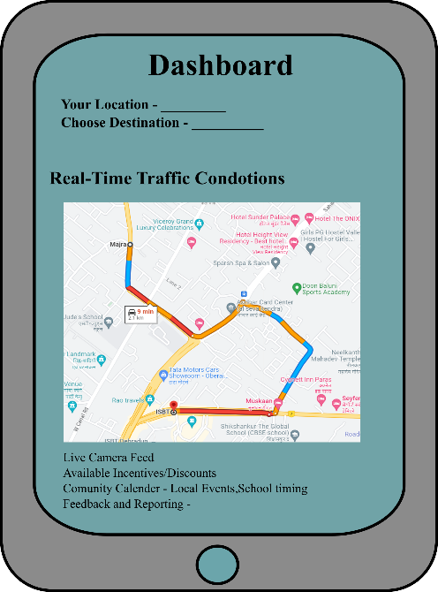

***Dashboard of the Application***

GREEN – SLIDING TRAFFIC

ORANGE – MODERATE TRAFFIC

RED – SLOWDOWNS TRAFFIC

1. **information communication Networks**: excessive-pace communication networks, consisting of fiber optic or wireless networks, are crucial for transmitting statistics among numerous additives of the system, along with traffic cameras, facts centers, and visitor's signal manipulation structures.
2. **GPS and Sensor technology**: cell gadgets and vehicles geared up with GPS and sensors can assist the machine and man or woman's actions, taking into consideration personalized direction suggestions and incentives.

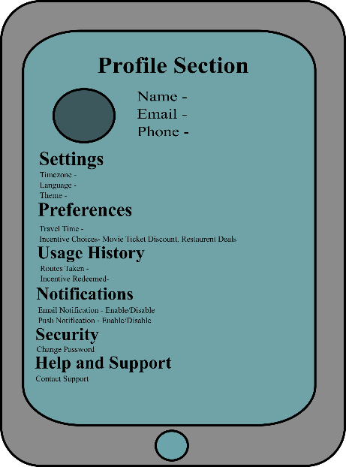

1. **Electronic toll series structures**: in which relevant, digital toll collection structures are used to control traffic and go with the flow on toll roads and bridges. those systems help lessen congestion by way of eliminating the want for physical toll booths.
2. **network hobby data resources**: The system integrates facts from diverse sources, such as faculty schedules, office hours, and nearby occasion calendars, to issue in network activities when optimizing site visitors drift and incentivizing journey.
3. **smart Parking Systems**: In some implementations, smart parking systems are utilized to guide commuters to available parking spaces, reducing the time spent trying to find parking, which can contribute to congestion.
4. **Roadside Sensors**: Roadside sensors, along with induction loop sensors, can offer real-time site visitor records to the device, assisting in traffic analysis and sign timing adjustments.
5. **traffic control middle**: A crucial control hub where visitors engineers and operators reveal the gadget's performance, respond to incidents, and make real-time modifications to visitor indicators and guidelines.
6. **Incentive Redemption factors**: physical locations or virtual structures wherein commuters can redeem incentives, such as discounts on leisure or retail purchases, for journeying in the course of off-top hours.
7. **CCTV tracking Rooms**: Rooms equipped with monitors and employees for tracking stay visitor's digicam feeds, tracking incidents, and making sure the safety of the device

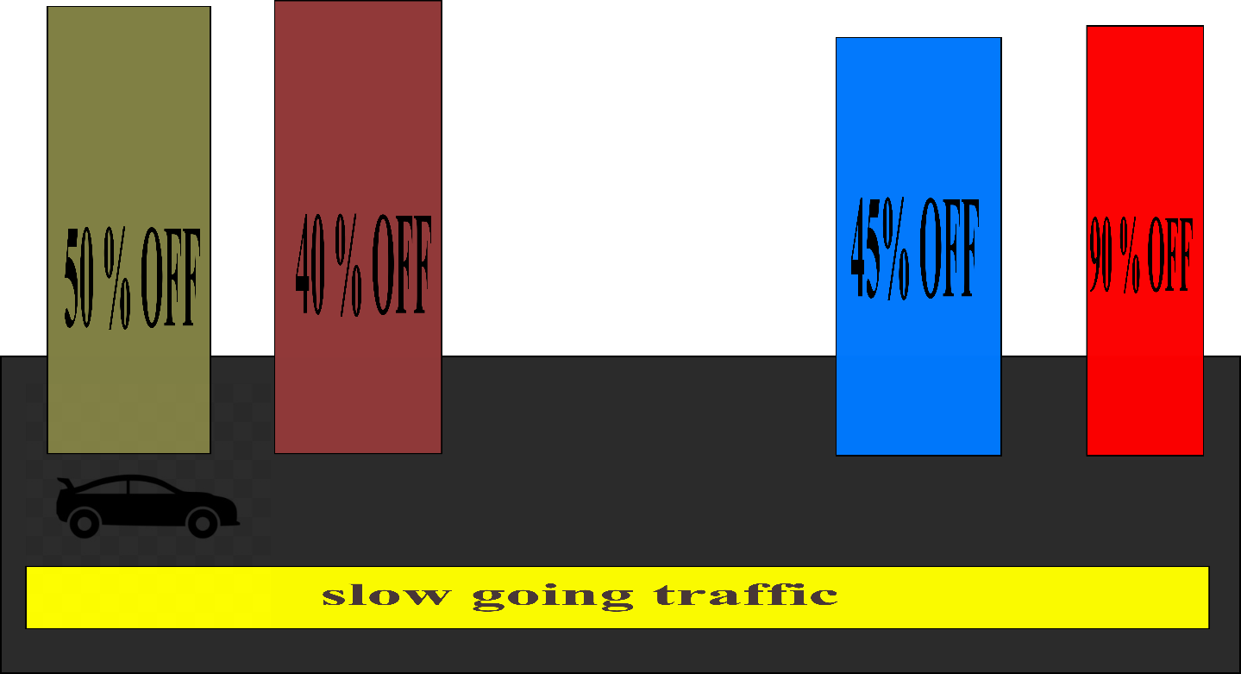

***“The diagram shows a car moving in slow traffic, and on the side, it's receiving options indicating how much discount is available, and it can go there and redeem its offer”***

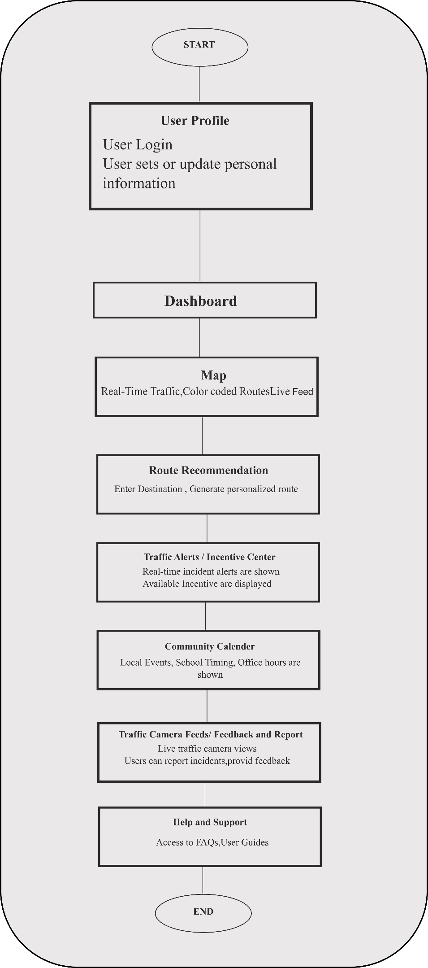

***FLOWCHART***

**2d. OPERATION/FUNCTION/USE.**

1. **Data Collection**: The machine constantly collects actual-time statistics from a variety of sources, which include traffic cameras, GPS-enabled gadgets, roadside sensors, and records on community activities. This data offers a comprehensive view of contemporary site visitor's conditions, road usage, and network schedules.
2. **Data evaluation**: superior statistics analytics and gadget-gaining knowledge of algorithms process the amassed statistics to perceive visitor patterns, congestion hotspots, and potential bottlenecks. these insights function as the foundation for decision-making inside the machine.
3. **traffic monitoring**: traffic cameras and sensors continuously reveal traffic float, identifying incidents including accidents, road closures, and congestion. those observations are relayed to the site visitor's control center.
4. **Visitor sign Optimization**: The machine dynamically adjusts site visitor's sign timings at intersections primarily based on real-time traffic records. It goals to enhance site visitors' drift with the aid of prioritizing the motion of automobiles on less congested routes.
5. **Dynamic path guidelines**: the usage of GPS and in-vehicle communication systems, the device affords personalized path pointers to commuters. It considers their cutting-edge vicinity, destination, and real-time site visitor situations to suggest the quickest and least congested routes.
6. **Incentive Provision**: The device gives incentives to inspire off-top travel. those incentives may include reductions on transportation costs, enjoyment, or buying for the duration of non-height hours. customers are notified of these incentives through variable message signs, cell apps, and digital conversation.
7. **traffic indicators**: Commuters obtain actual-time site visitors signals and updates thru diverse channels, which include cellular apps, variable message signs and symptoms, and in-automobile systems. those indicators inform them approximately incidents, congestion, and the supply of incentives.
8. **Community Hobby Integration**: The machine elements in community sports, together with faculty start and give up instances, office hours, and local events, to tailor tips and incentives that align with the metropolis's daily agenda.
9. **feedback and interaction**: The system permits commuters to offer comments and engage with it through cell apps or other systems. These comments can consist of incident reporting, hints for enhancements, and incentive redemption.
10. **visitors management middle Operations**: site visitors engineers and operators in the visitor's control center reveal the machine's performance. They reply to site visitor incidents, modify traffic sign timings, and make actual-time selections to control and alleviate congestion effectively.
11. **smart Parking guidance**: If included, the machine can manual commuters to available parking areas, decreasing the time spent looking for parking and in addition easing visitor congestion.
12. **Incident control**: inside the occasion of accidents, road closures, or other incidents, the device provides actual-time updates to commuters and gives alternative routes to decrease disruptions.
13. **Incentive Redemption**: Commuters can redeem incentives, such as discounted movie tickets or retail purchases, at bodily places or via digital structures for visiting at some stage in off-top hours.
14. **Eco-Friendly Mode Promotion**: The system may additionally promote Eco-Friendly Mode Promotion transportation alternatives, consisting of cycling and electric-powered scooters, in the course of positive times to lessen the number of automobiles on the road

**2e. ALTERNATIVES**:

Those options might also range in terms of technology and processes. some alternatives include:

1. **Conventional visitors signal Synchronization**: rather than employing dynamic site visitors signal optimization, cities can preserve the usage of fixed timing plans for traffic signals. this is a much less data-pushed technique that relies on preset timing patterns.
2. **manual Incident control**: In the area of automated incident detection and response, towns can rely upon guide incident management by dispatching employees to reply to accidents and avenue closures without using advanced information analytics.
3. **Public Transportation growth**: rather than specializing in incentivizing individual vehicle tours, cities can spend money on increasing public transportation systems, and increasing the capacity and insurance of buses and trains to reduce the need for private motors.
4. **Carpooling initiatives**: selling carpooling and ridesharing as an opportunity to solo ride is an opportunity approach to lowering congestion all through top hours. Carpooling apps and carpool lanes on highways are a part of this approach.
5. **Congestion Pricing growth**: rather than imparting incentives for off-height tours, towns can increase congestion pricing techniques, charging cars a fee for journeying at some point of height hours to deter congestion.
6. **Eco-Friendly Transportation Focus**: cities can be conscious of selling Eco-Friendly Transportation Focus, inclusive of biking, on foot, and electric powered scooters, as options for private vehicles.
7. **Localized visitors management**: some cities may pick out to put into effect localized traffic control solutions in unique regions instead of adopting a comprehensive town-huge device.
8. **traditional Navigation Apps**: continuing to rely totally on traditional navigation apps like Google Maps and Waze for visitor's facts and direction pointers.
9. **No Incentive programs**: Forgoing the implementation of incentive programs altogether and relying entirely on traditional site visitors management strategies.
10. **No network pastime Integration**: Ignoring network-particular activities and schedules while making plans visitor control and incentive techniques.

**2f. NEW FEATURES.**

these new functions are believed to be novel and represent advancements in city mobility optimization. a number of the key new features of this invention include:

1. **actual-Time Dynamic Traffic Optimization**: The gadget continuously collects and analyzes real-time facts to dynamically optimize site visitors' waft, which includes site visitors' sign timings and direction pointers, primarily based on current situations. This real-time adaptability is a singular function as compared to standard fixed visitors sign synchronization.
2. **Behavior-driven incentives**: The gadget introduces incentives, such as reductions in enjoyment and retail purchases, to encourage commuters to travel for the duration of off-peak hours. these incentives are tailor-made to individual options and travel patterns, offering a new method of reducing congestion.
3. **network interest Integration**: by considering faculty hours, office commutes, and local events, the system aligns traffic management strategies with the specific agenda of the network. this feature acknowledges the significance of local activities in traffic optimization.
4. **records-pushed decision-making**: The device relies on advanced data analytics and device studying to make proactive decisions for site visitor management. It makes use of facts from numerous assets to beautify the performance of city mobility, which represents a great development over traditional strategies.
5. **personalized course suggestions**: Commuters get hold of customized course suggestions based totally on their modern vicinity, destination, and actual-time visitor situations. this feature provides a better level of person-centric carrier compared to conventional navigation apps.
6. **Multi-Channel visitors alerts**: The system affords actual-time traffic alerts through numerous communication channels, including mobile apps, variable message signs and symptoms, and in-car structures, making sure that commuters are well-knowledgeable approximately visitors situations.
7. **Proactive Incident Reaction**: The device can automatically hit upon and reply to site visitor incidents, together with injuries and road closures, by suggesting opportunity routes and providing incident updates to limit disruptions.
8. **Incentive Redemption factors**: Commuters can redeem incentives for traveling for the duration of off-height hours, developing an interaction between the machine and customers that encourages behavior trade.
9. **traffic digicam network**: the usage of an in-depth community of traffic cameras for actual-time visitors monitoring and records series is a crucial feature that helps site visitors evaluation and control.

**2g. ADVANTAGES.**

Those blessings include:

1. **Real-time site visitors Optimization**: The device dynamically adjusts visitor indicators and provides actual-time direction recommendations, resulting in decreased congestion and shorter travel times. this is an enormous development over the fixed timing plans of traditional site visitors' signal synchronization.
2. **Reduced congestion**: By incentivizing off-top journeys, the device efficiently spreads out the site visitor's load, reducing congestion in the course of rush hours, which is a continual difficulty in traditional site visitor control methods.
3. **customized recommendations**: The system offers personalized route recommendations primarily based on man or woman preferences and real-time situations, improving the commuter's experience and promoting green travel, a function not determined in traditional navigation apps.
4. **Behavior-pushed incentives**: conventional methods lack incentives to inspire commuters to trade their tour conduct. The gadget introduces focused incentives to shift tour styles and reduce congestion, which is a unique and powerful method.
5. **network activity Integration**: by way of considering neighborhood activities and schedules, the machine aligns traffic management with the network's wishes, resulting in more harmonious and efficient city mobility revel in.
6. **information-driven decision-making**: The system's use of superior data analytics and machine getting-to-know allows proactive and records-knowledgeable traffic control decisions, which considerably enhance incident reaction and traffic waft in comparison to traditional techniques.
7. **Multi-Channel visitors alerts**: The device keeps commuters informed about traffic situations through various channels, ensuring that they obtain well-timed updates and have the information needed to make informed journey selections.
8. **Proactive Incident Response**: The system mechanically detects and responds to traffic incidents, suggesting opportunity routes and imparting incident updates. this selection minimizes disruptions and complements visitors' control.
9. **Incentive Redemption factors**: Commuters can redeem incentives for the off-top tour, fostering engagement and selling conduct alternate, which is a characteristic missing in traditional visitor management.
10. **progressed consumer enjoy**: The device offers a greater person-centric and interactive enjoy through providing personalized pointers, incentives, and actual-time updates, enhancing the overall high-quality of urban mobility for commuters.
11. **Sustainable Transportation**: by decreasing congestion, the machine indirectly contributes to lower gas consumption, reduced emissions, and a greater sustainable urban transportation surroundings, addressing environmental issues

|  |  |
| --- | --- |
| **PART III. PERSON SUBMITTING FORM** | |
| FULL NAME | SUBMISSION DATE |
| MAILING ADDRESS | BUSINESS TELEPHONE |
| E-MAIL ADDRESS | CELL PHONE |